NextUp: A One-Stop Media Tracker
Julia Reynolds & Stephen Stanwood (Group 11)
CS 340: Introduction to Databases

Actions Based on Previous Feedback
None. We have received full marks so far and no specific suggestions for improvement. Test Site URL http://classwork.engr.oregonstate.edu:9130

Overview
In 2026, we have basically unlimited options of what to watch, read, and follow at all times. The problem is no longer having something to do—it's keeping tabs on all of our possible entertainment options and picking the right one at the right time. Various tracking apps have sprung up for different categories of media: Letterboxd for movies, Goodreads for books, etc. But why should consumers have to split their attention across multiple interfaces and accounts just to keep tabs on what's going on? We need a one-stop shop where people can answer the question, "What should I do right now?"
Our website and database will serve as the backend support for a consumer-facing app for roughly five hundred users, each of whom will maintain a library of roughly twenty items and make approximately ten updates to their lists per week. Our overall goal is to delight users with entertainment options by letting them skip the hassle of deciding what to do next.

Database Outline ● Users
○ Purpose:
■ Stores information about the various individuals using our application ○ Attributes:
■ userID: integer, auto_increment, not NULL, PK
■ username: varchar, not NULL, unique
■ email: varchar, not NULL, unique ○ Relationships:
■ 1:M between Users and UserTrackerEntries, using userID as a FK in UserTrackerEntries
■ M:N between Users and Media Items via UserTrackerEntries
■ M:N between Users and SportsEvents via UserTrackerEntries

● MediaItems
○ Purpose:
■ Stores information about all the various media options users can choose from that are not time-specific (i.e., that are not sports).
○ Attributes:
■ mediaItemID: integer, auto_increment, not NULL, PK
■ mediaType: enum('MOVIE','SHOW','BOOK'), not NULL
■ title: varchar, not NULL
■ releaseDate: datetime, NULL
■ runtimeMins: integer, NULL
■ creator: varchar, NULL ■ platform: varchar, NULL ○ Relationships:
■ M:N between Users and MediaItems through UserTrackerEntries, using mediaItemID as a FK inside of UserTrackerEntries

● SportsEvents
○ Purpose:
■ Stores information about scheduled sports events that users may choose to track to watch either live or recorded after they air.
○ Attributes
■ sportsEventID: integer, auto_increment, not NULL, PK
■ typeOfSport: varchar, not NULL
■ homeTeam: varchar, not NULL
■ awayTeam: varchar, not NULL
■ startTime: datetime, not NULL
■ runtimeMins: integer, NULL
■ recordingIsAvailable: boolean, NULL
■ platform: varchar, NULL ○ Relationships:
■ M:N between Users and SportsEvents through UserTrackerEntries, using sportsEventID as a FK inside of UserTrackerEntries
● UserTrackerEntries ○ Purpose:
■ Stores information about a particular user’s tracking relationship with a specific media or sports event. ○ Attributes
■ entryID: integer, auto_increment, not NULL, PK
■ userID: integer, not NULL, FK → Users(userID)
■ mediaItemID: integer, NULL, FK → MediaItems(mediaItemID)
■ sportsEventID: integer, NULL, FK → SportsEvents(sportsEventID)
■ status: enum('TO_WATCH','WATCHING','WATCHED')
■ savedAt: datetime, not NULL ■ completedAt: datetime, NULL ○ Constraints:
■ Each record in this tracker must reference either a mediaItemID or sportsEventID—but not both.
○ Relationships:
■ 1:M between Users and UserTrackerEntries, with userID as a FK inside of UserTrackerEntries
■ 1:M between MediaItems and UserTrackerEntries, with mediaItemID as a FK inside of UserTrackerEntries
■ 1:M between SportsEvents and UserTrackerEntries, with sportsEventID as a FK inside of UserTrackerEntries

Entity-Relationship Diagram
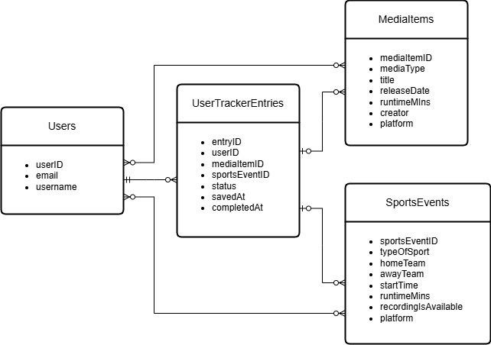

Schema Diagram
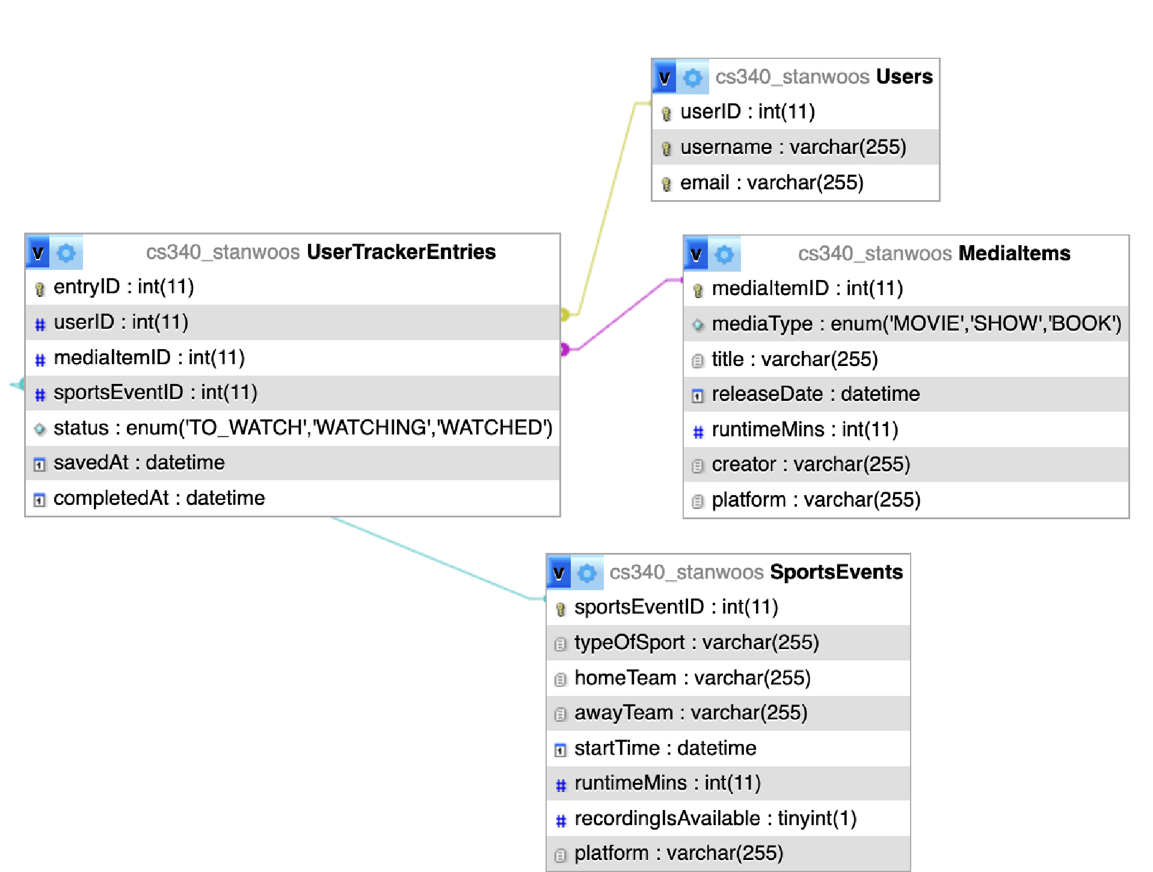

Sample Data

Users
userID | username | email
1 | julia | julia@nextup.dev
2 | stephen | stephen@nextup.dev
3 | soph | soph@nextup.dev

MediaItems mediaItemID mediaType title releaseDate runtimeMins creator platform
1 | MOVIE | Big Fish |  | 2003-12-10 |  | 125 | Tim  Burton | Prime Video
2 | SHOW | The Americans |  | 2013-01-30 |  | 45 | Joe  Weisberg | FX
3 | BOOK | The World  According to Garp |  | 1978-03-01 |  | null | John Irving | null
SportsEvents  sportsEventID | typeOfSport | homeTeam | awayTeam |  | startTime | runtimeMins | recordingIs Available | platform
1 | Football | Pittsburgh Steelers | Arizona Cardinals |  | 2009-02-01  18:31 | 218 | true | NBC
2 | Basketball | Golden State Warriors | Boston Celtics |  | 2022-06-16  21:00 | 140 | true | ABC
3 | Baseball | Chicago Cubs | Cleveland Guardians |  | 2016-11-02  20:02 | 268 | true | FOX

UserTrackerEntries entryID userID mediaItemID sportsEventID status savedAt completedAt
1 1 | 2 | null | WATCHING | 2026-01-10 08:00 | null
2 3 | null | 2 | TO_WATCH | 2026-01-12 18:30 | null
3 2 | 1 | null | WATCHED | 2026-01-05 20:00 | 2026-01-06 21:45
4 2 | null | 1 | WATCHED | 2026-01-12 09:00 | 2026-01-12 12:45
5 3 | 3 | null | TO_WATCH | 2026-01-15 10:30 | null

Citations
Draw.io used to create the Entity-Relationship Diagram. phpMyAdmin used to create the Schema Diagram.
No other external sources used.

